ATTENTION BADGE HOLDERS

YAKIMA AIR TERMINAL’S
GATE CODES WILL BE CHANGING
JUNE 1, 2019
PLEASE CONTACT THE AIRPORT OFFICE TO RECEIVE YOUR NEW CODE

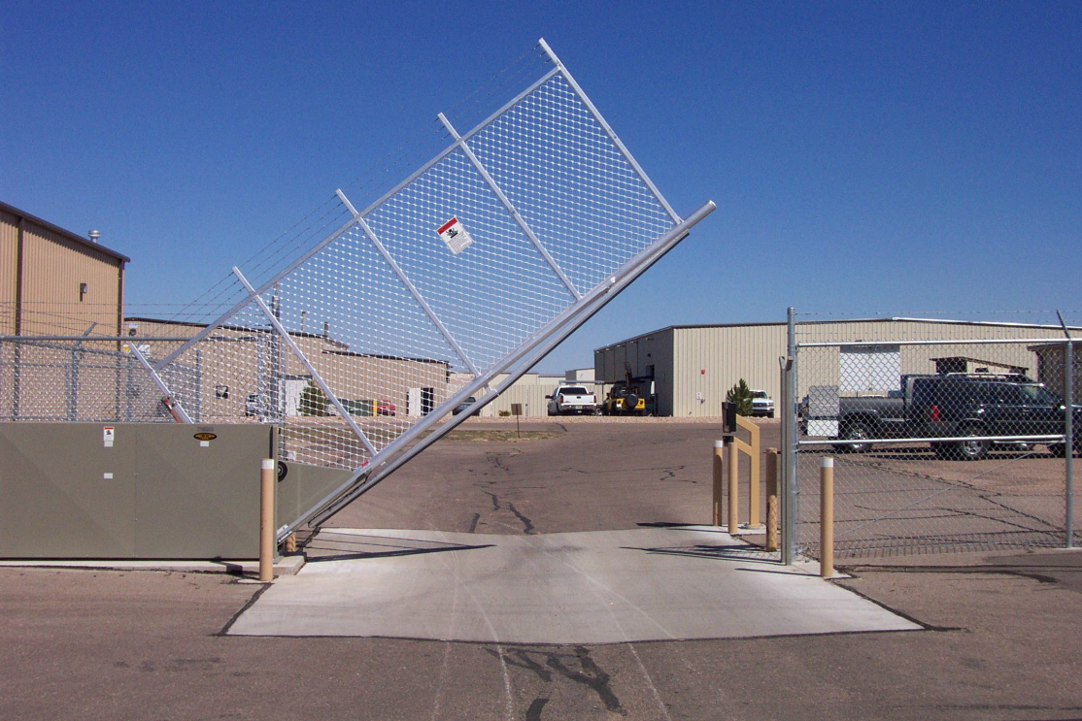

Administration Office: 509-575-6149

